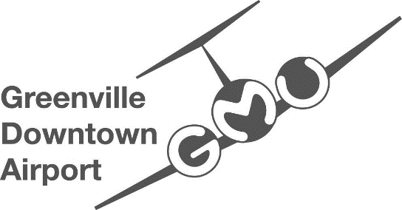
NOTICE OF AVAILABILITY

NOTICE OF PUBLIC COMMENTS PERIOD

REQUEST FOR COMMENTS

DRAFT ENVIRONMENTAL ASSESSMENT FOR
RUNWAY 1-19 RSA IMPROVEMENT PROJECT
GREENVILLE DOWNTOWN AIRPORT, SC

Notice is hereby given that a Draft Environmental Assessment (DEA) was prepared to evaluate the potential environmental impacts resulting from the proposed Runway Safety Area (RSA) Improvements Project (“Proposed Action”) as per Federal Aviation Administration (FAA) safety standards at the Greenville Downtown Airport (GMU).
The Proposed Action is to comply, to the extent possible, with FAA RSA safety criteria for federally obligated airports included in the FAA Airport Design Advisory Circular. The RSA project is necessary for GMU to meet operational runway safety standards required by FAA, improve the safety areas, and address the Runway 1-19 RSA deficiencies and constraints.
This DEA was prepared in accordance with the National Environmental Policy Act of 1969 (NEPA), FAA Order 5050.4B – NEPA Implementing Instructions for Airport Actions, and FAA Order 1050.1F - Environmental Impacts: Policies and Procedures and related statutes and orders.
The document is available for review during a 30-day comment period at the following locations, during normal business hours:

GMU Administration Office  at GMU Airport  100 Tower Dr Unit 2  Greenville, SC 29607  Ph.: (864) 242-4777 | Hughes Main Library  Public Files  25 Heritage Green Place  Greenville, SC 29601  Ph.: (864) 242-5000

Also, an electronic copy of the DEA can be accessed through the following link:
https://www.greenvilledowntownairport.com/ (Google chrome browser should be used)
A Public Meeting will be held to present details discussed in the DEA. The public is encouraged to attend this “open house” style meeting to get more information and to ask questions. The Public Meeting will be held on Thursday, April 7, 2022. Doors will open at 6:00 PM. Airport and project staff will be on hand to provide details of the proposed project until the close of the meeting at 8:00 PM. The Airport will host this meeting at the following location:

Runway Café Hangar
at Greenville Downtown Airport
21 Airport Road Ext.
Greenville, South Carolina 29607

Special Accommodations: If you need special accommodations or need an interpreter or document translator because English is not your primary language, or if you have other communication or hearing needs, please contact GMU via email at ken@greenvilledowntownairport.com and GMU-EA@mjinc.com at least one week before the Public Meeting. Note, the Runway Café will not be serving food during the Public Meeting.
Written comments on the DEA should be sent to either of the following addresses:

GMU-EA@mjinc.com
Or
David Rosa
McFarland Johnson, Inc.
330 East Coffee Street
Greenville, South Carolina 29601
Phone: (305) 705-4871

The document will be available for review beginning on March 21, 2022. Comments received on the DEA in writing on or before the close of business on April 30, 2022 will be considered and addressed in the Final Environmental Assessment (FEA) for the proposed action. Based on a review of the FEA, the FAA will determine the significance of potential impacts and either issue a Finding of No Significant Impact (FONSI) or require a more detailed study.

